|  |  |
| --- | --- |
| Nama | : La Ode Muhammad Gazali |
| NIM | : 222212696 |
| Kelas | : 2KS2 |

**PRA PERTEMUAN 5 PEMROGRAMAN BERBASIS OBJEK**

**(UML dan Class Diagram)**

**Studi Kasus**

* A university consists of multiple faculties which are composed of university various institutes. Each faculty and each institute has a name. An address is known for each institute.
* Each faculty is led by a dean, who is an employee of the university.
* The total number of employees is known. Employees have a social security number, a name, and an e-mail address. All employees have same obligation, namely to take the attendance. There is a distinction between research and administrative personnel.
* Calculation of attendance percentages are different for both research and administrative personnel. Administrative personnel: based on routine attendance per day. Research personnel: based on the number of teaching hours
* Research associates are assigned to at least one institute. The field of study of each research associate is known. Furthermore, research associates can be involved in projects for a certain number of hours, and the name, starting date, and end date of the projects are known. Some research associates teach courses. They are called lecturers.
* Courses have a unique number (ID), a name, and a weekly duration in hours.

1. **Idenifikasi Classes**

Ekstrak kata benda (noun) pada studi kasus tersebut:

* A **university** consists of multiple **faculties** which are composed of university various **institutes**. Each faculty and each institute has a name. An address is known for each institute.
* Each faculty is led by a **dean**, who is an **employee** of the university.
* The total number of employees is known. Employees have a social security number, a name, and an e-mail address. All employees have same obligation, namely to take the attendance. There is a distinction between **research** and **administrative personnel**.
* Calculation of attendance percentages are different for both research and administrative personnel. Administrative personnel: based on routine attendance per day. Research personnel: based on the number of teaching hours
* Research associates are assigned to at least one institute. The field of study of each research associate is known. Furthermore, research associates can be involved in **projects** for a certain number of hours, and the name, starting date, and end date of the projects are known. Some research associates teach **courses**. They are called **lecturers**.
* Courses have a unique number (ID), a name, and a weekly duration in hours.

1. **Eliminasi class yang tidak relevan**

Dari kata benda yang telah diekstrak, selanjutnya untuk menetapkan class apa saja yang harus dibuat, maka terlebih dahulu perlu dieliminasi kata benda yang kurang sesuai dengan proses bisnis pada studi kasus tersebut. Berikut class yang harus dieliminasi:

* University, karena kita sedang memodelkan sistem di universitas
* Dean, dapat gabungkan dengan employee karena tidak memiliki atribut lain yang berbeda dengan employee

Berikut Classes yang telah diidentifikasi dan siap diimplementasikan:

* Faculty
* Institute
* Employee
* Research Associate
* Administrative Employee
* Project
* Course
* Lecture

1. **Identifikasi Atribut**

|  |  |
| --- | --- |
| Statement | Atribut |
| A university consists of multiple faculties which are composed of university various institutes.  “Each faculty and each institute has a name. An address is known for each institute”  “Each faculty is led by a dean, who is an employee of the university.” | * Faculty * name (String) * dean (Employee) * Institute * name (String) * address (String) |
| “The total number of employees is known. Employees have a social security number, a name, and an e-mail address” | * Employee * ssNo (int) * name (String) * email (String) * Counter (Iint) |
| “There is a distinction between research and administrative personnel”  “Administrative personnel: based on routine attendance per day. Research personnel: based on the number of teaching hours”  “Research associates are assigned to at least one institute. The field of study of each research associate is known. Furthermore, research associates can be involved in projects for a certain number of hours, and the name, starting date, and end date of the projects are known. Some research associates teach courses. They are called lecturers.” | * Administrative Employee * routineAttendence(int) * Research Associate * fieldfOfStudy (String) * teachingHours (int) * Project * name (String) * start (Date) * end (Date) |
| “Some research associates teach courses. They are called lecturers.”  “Courses have a unique number (ID), a name, and a weekly duration in hours.” | * Course * name (String) * id (int) * duration (int) * Lecture * Courses [] (Course) |

1. **Class Diagram University**

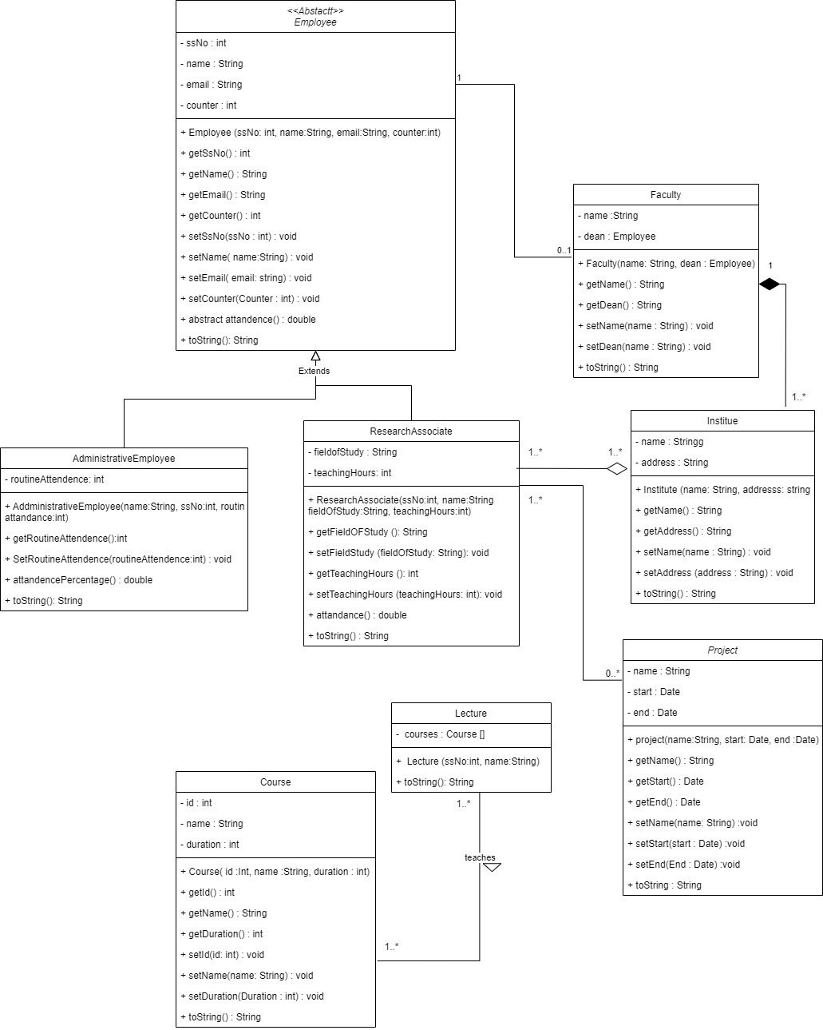

1. **Implementasi Program**

**Employee.java**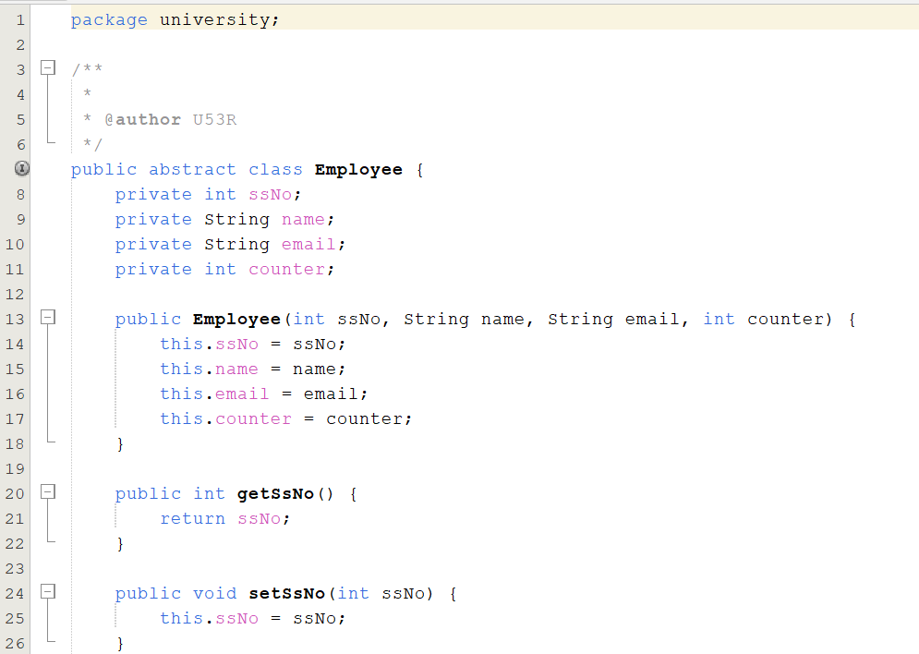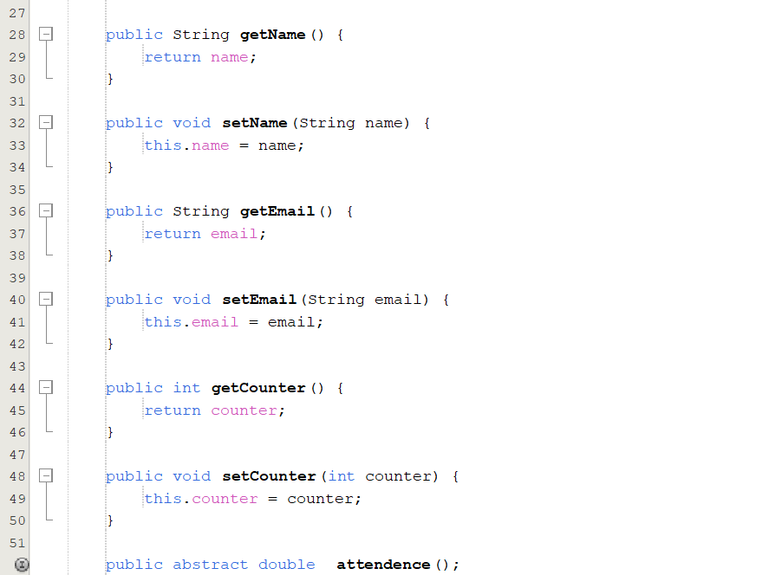

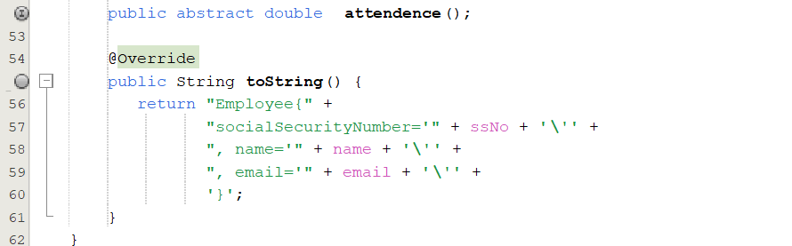

**Faculty.java**

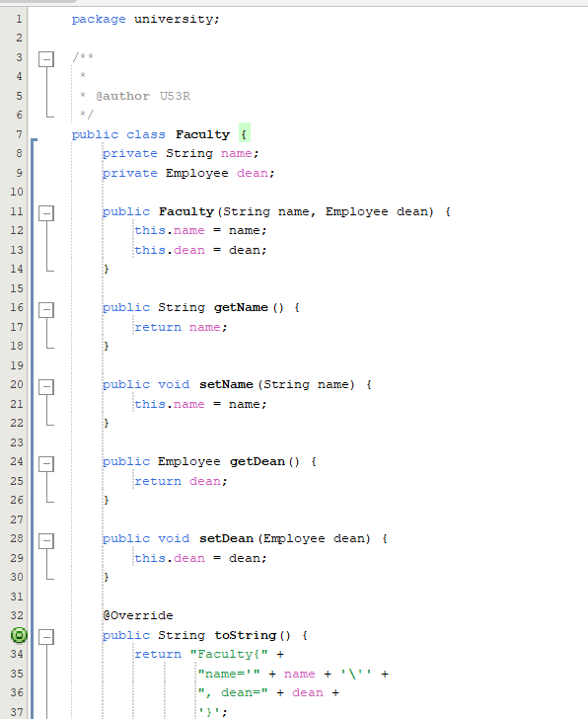

**Institute.java**

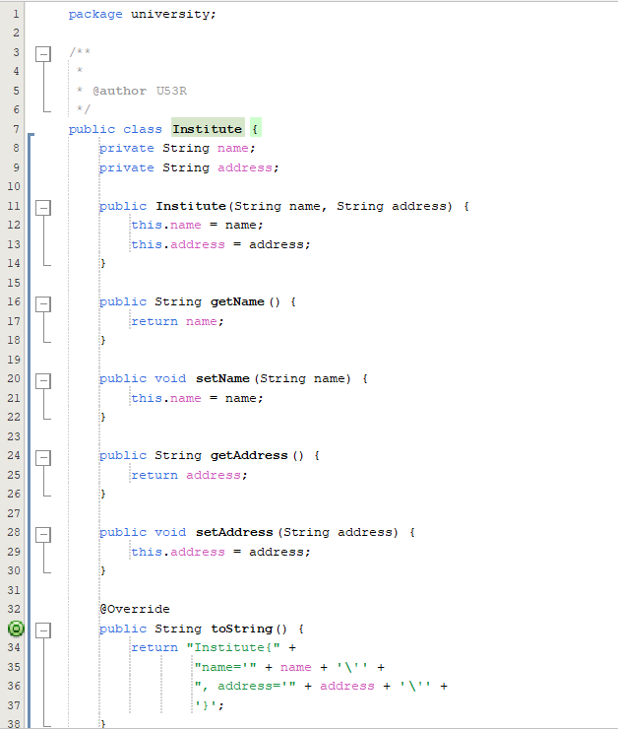

**AdministrativeEmployee.java**

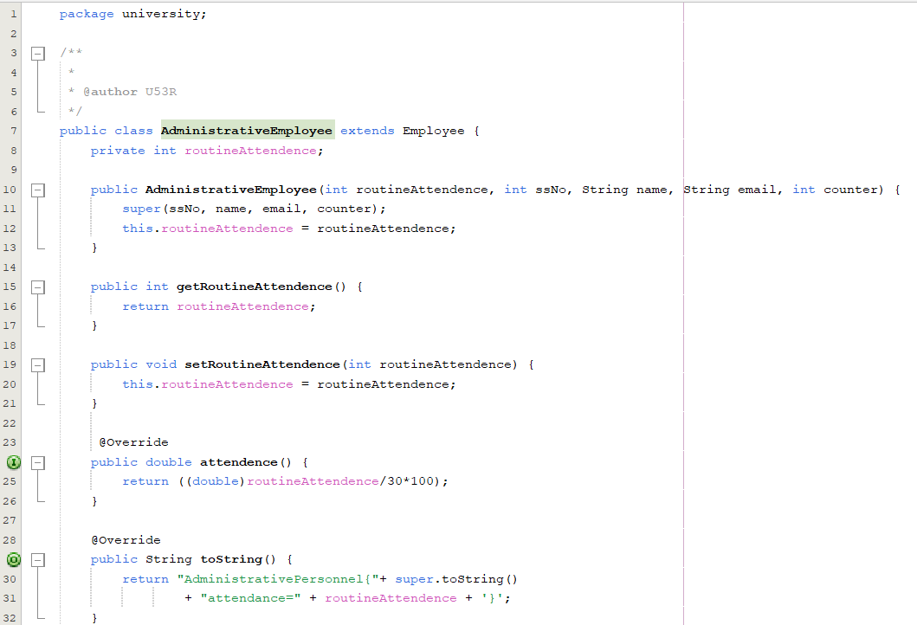

**ResearchAssociate.java**

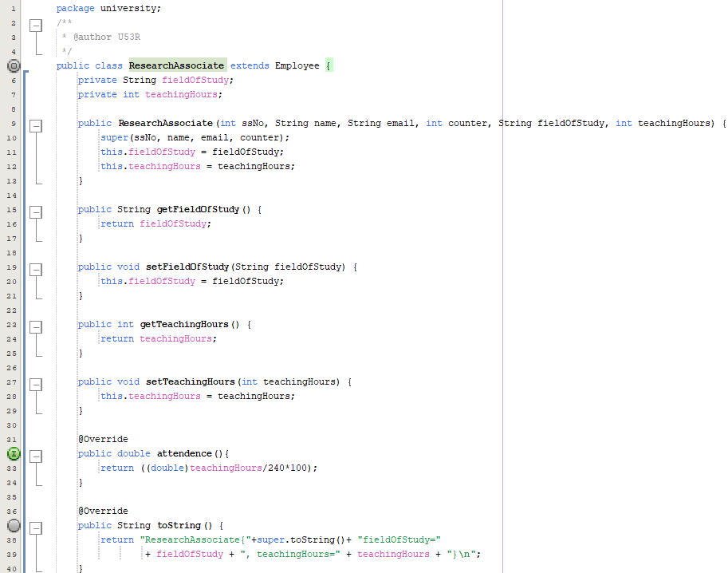



**Lecture.java**

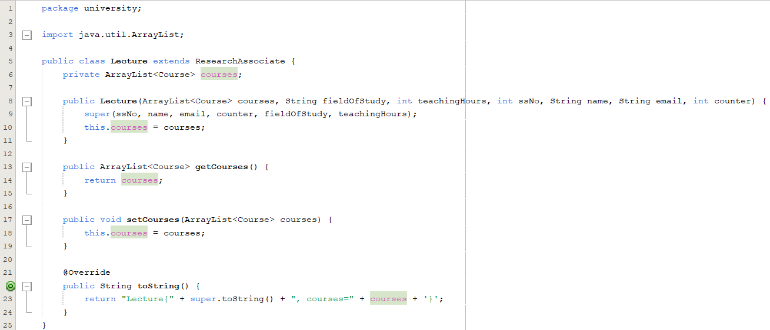

**Course.java**

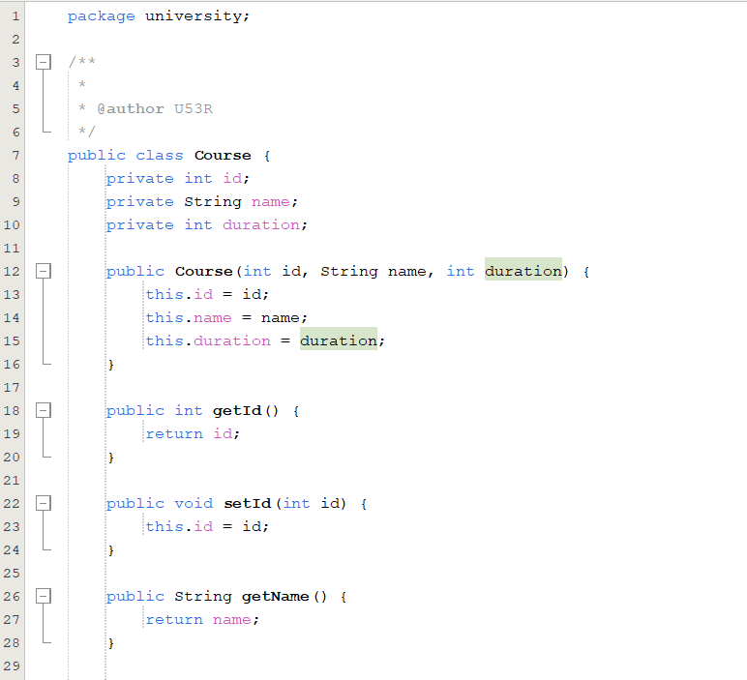

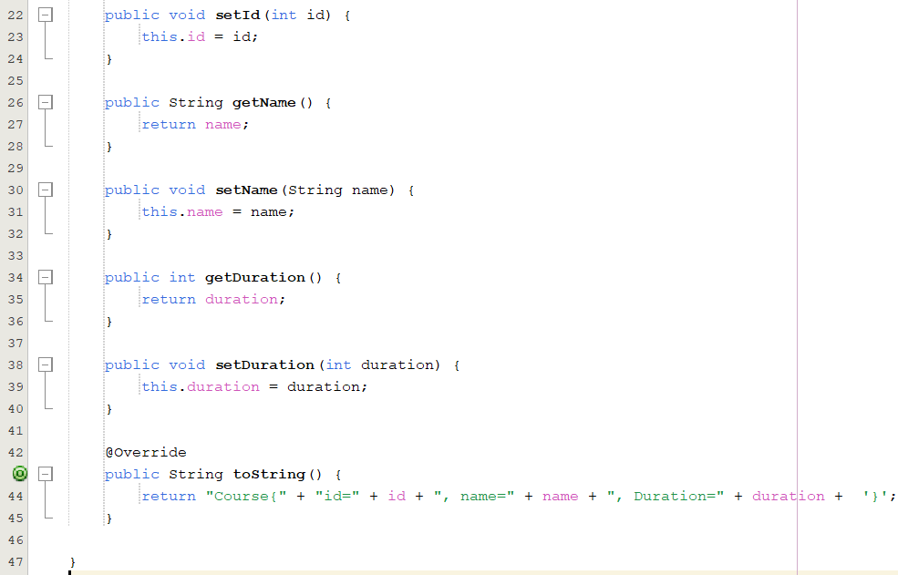

**Project.java**

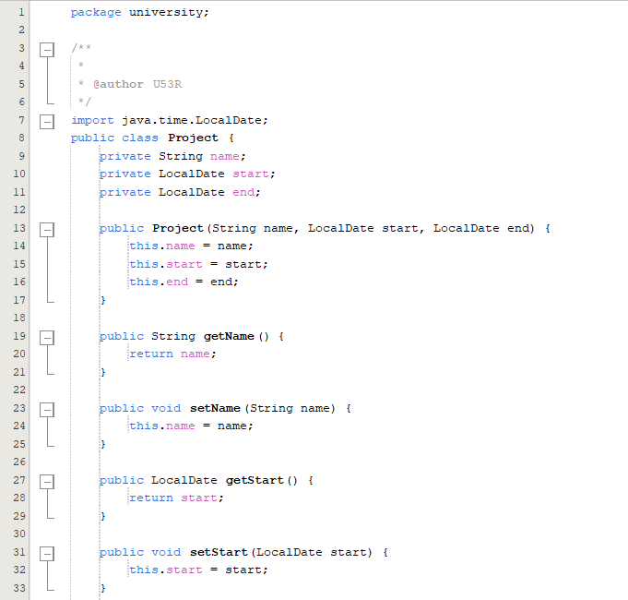

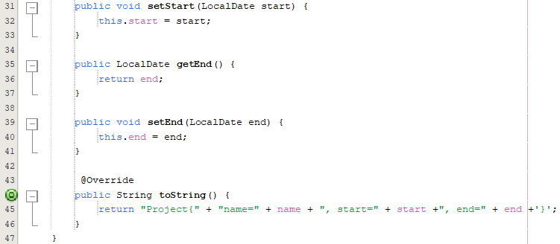

**University.java (main class)**

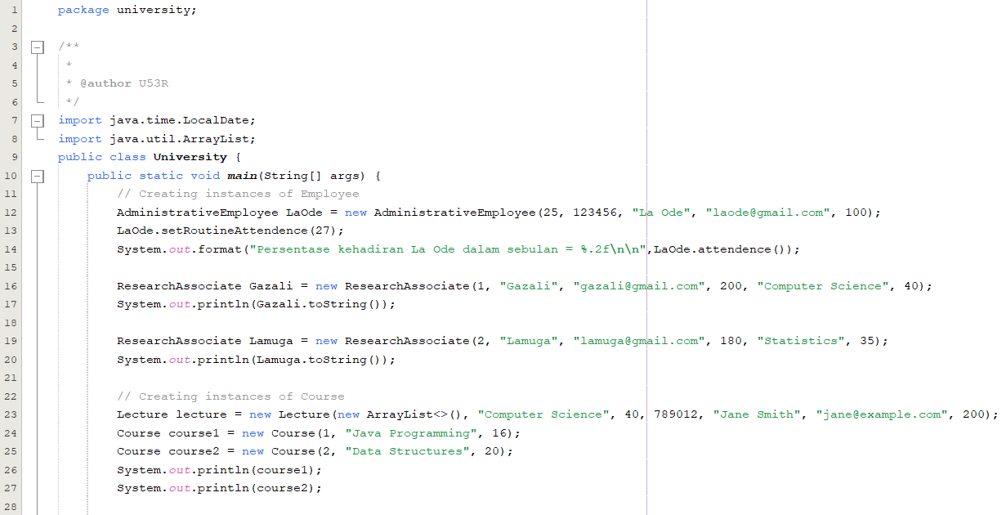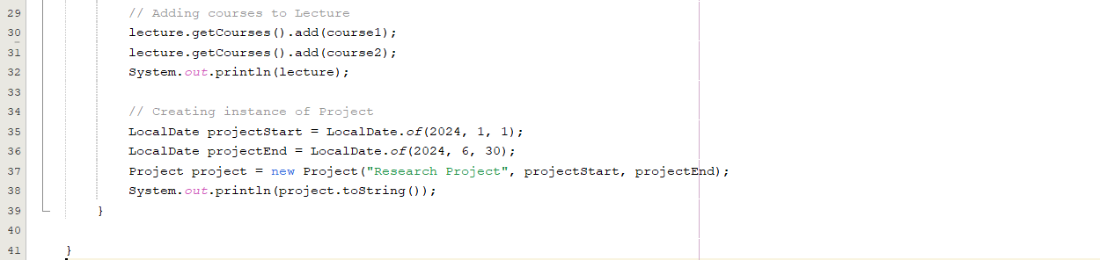

**Output**

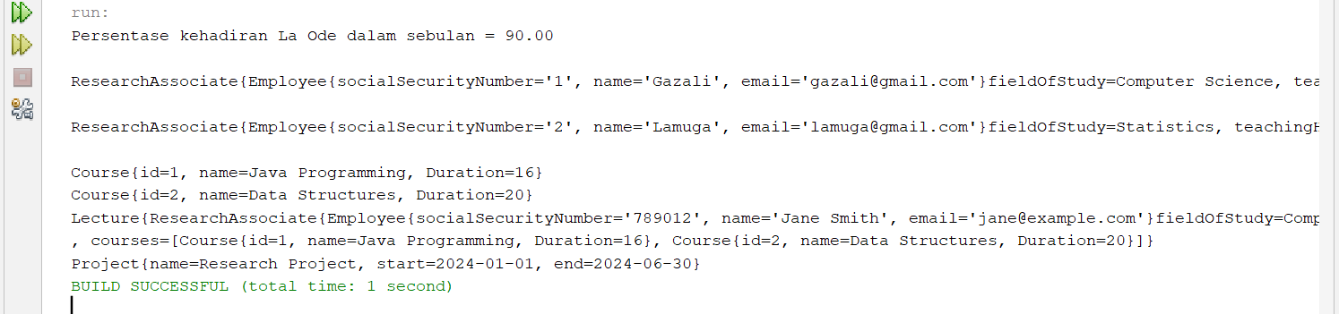

run:

Persentase kehadiran La Ode dalam sebulan = 90.00

ResearchAssociate{Employee{socialSecurityNumber='1', name='Gazali', email='gazali@gmail.com'}fieldOfStudy=Computer Science, teachingHours=40}

ResearchAssociate{Employee{socialSecurityNumber='2', name='Lamuga', email='lamuga@gmail.com'}fieldOfStudy=Statistics, teachingHours=35}

Course{id=1, name=Java Programming, Duration=16}

Course{id=2, name=Data Structures, Duration=20}

Lecture{ResearchAssociate{Employee{socialSecurityNumber='789012', name='Jane Smith', email='jane@example.com'}fieldOfStudy=Computer Science, teachingHours=40}

, courses=[Course{id=1, name=Java Programming, Duration=16}, Course{id=2, name=Data Structures, Duration=20}]}

Project{name=Research Project, start=2024-01-01, end=2024-06-30}

BUILD SUCCESSFUL (total time: 1 second)